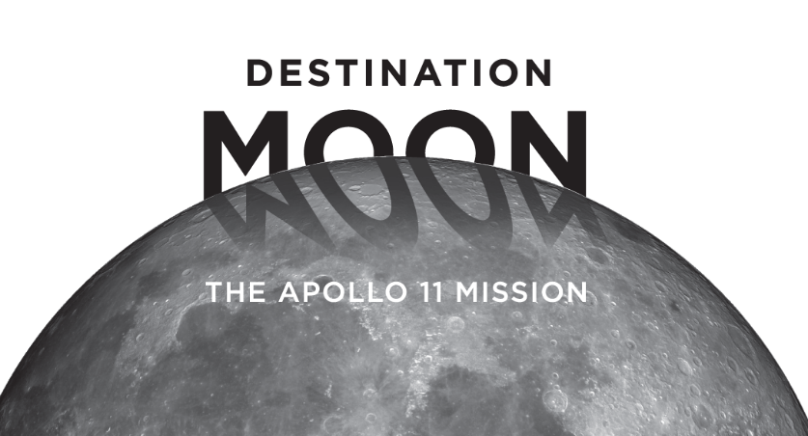

Join us at the History Center to explore
Destination Moon: The Apollo 11 Mission and more!

When: Saturday, October 13
Getting There: A bus will leave the Homewood Early Learning Hub at 10:30 a.m. and return at 2:30 p.m.
Food: Lunch will be available from 12:00 until 12:30 p.m.
in the History Center’s Multipurpose Room
Activities: After exploring Destination Moon, families can create in the Discovery Place kids gallery, play bocce in the Western Pennsylvania Sports Museum, and go down the slide in Kidsburgh!
Cost: It’s free, including transportation and food!
Sign Up: Contact Jan Jones at janj@tryingtogether.org or
412-421-3889, x108

