### Instructions for Responding to the 2019 Market Rate Survey using Provider Self Service

Providers should complete the following steps to update rates for full-time and part-time care for all age groups served and to indicate whether the location accepts blended rates. In the example below, updates to the location’s weekly rates are effective 10/01/2019, and the location accepts blended rates for the school year with an effective date of 09/01/2019.

1. Click **UPDATE** on the Location Rates Summary page.

The Edit Private Pay Rates window appears.

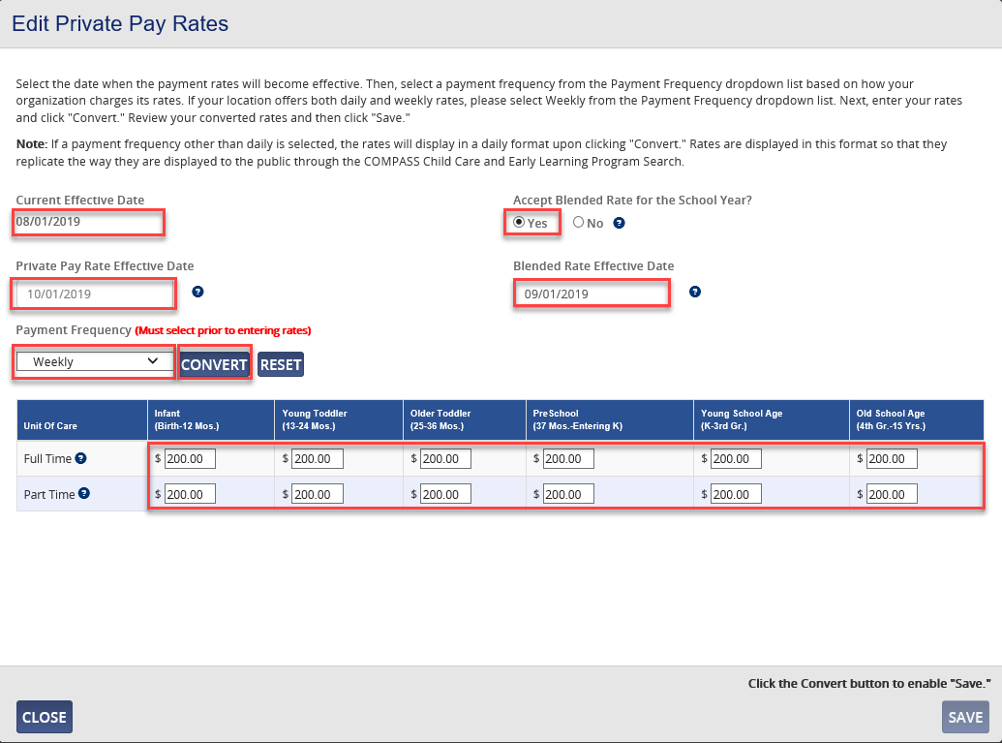

1. Click the **Yes** radio button for *Accept Blended Rate for the School Year?*
2. Enter the Private Pay Rate Effective Date of **10/01/2019**. Please note: You will need to update the effective date **if there are no changes to the current rates** or it will not count as a response to the survey.
3. To accept or refuse the blended rate, enter the Blended Rate Effective Date of **09/01/2020**, as the changes to blended rates always begin on September 01 of a given school year in the future.
4. Select **Weekly** in the Frequency drop-down list.
5. Enter the rates for each Full Time and Part Time age group served.
6. Click **CONVERT**.

The weekly rates entered are converted to daily rates.

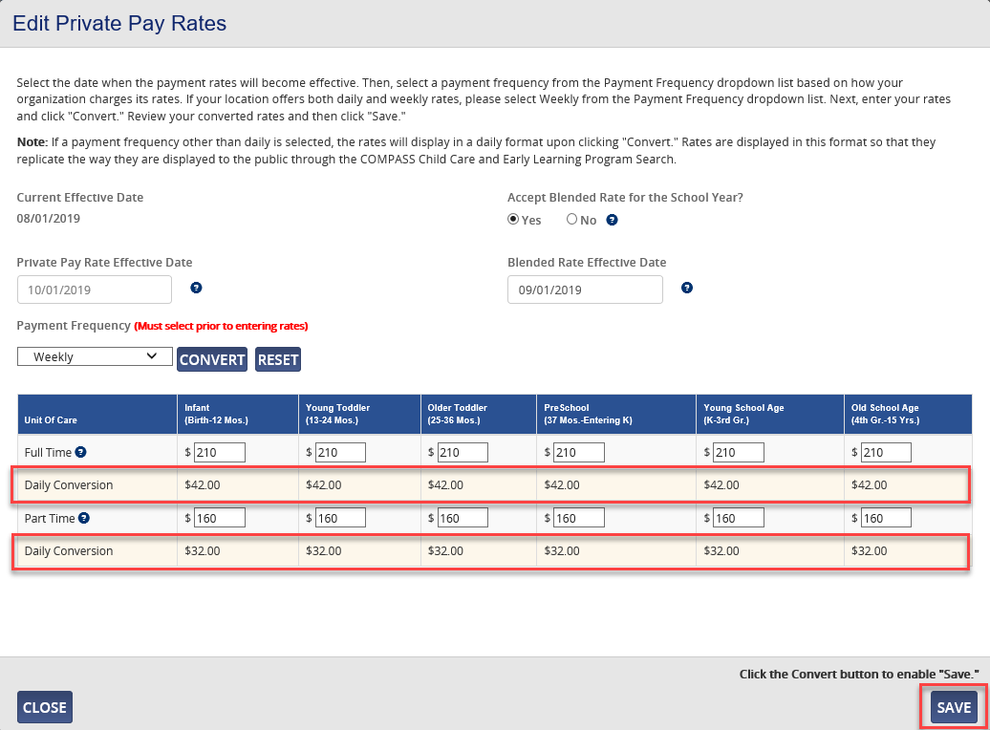

1. Review the daily rates to ensure the weekly rates entered are correct. If incorrect, reenter the weekly rates.
2. Click **SAVE**.

The following window appears.

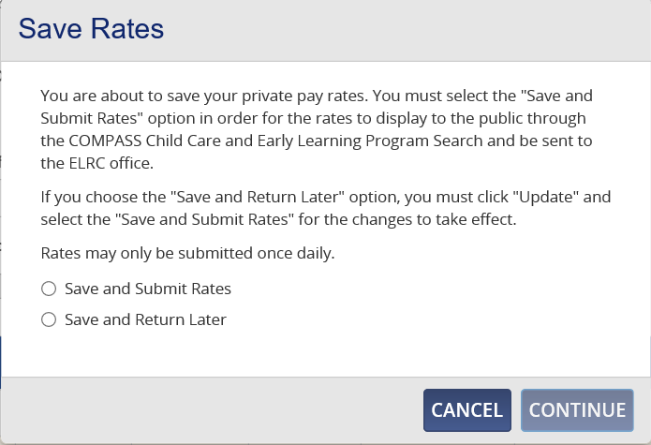

1. Click the radio button next to the preferred option.
2. Click **CONTINUE**.
3. If the radio button for Save and Submit Rates was clicked, the confirmation message appears, and the Private Pay Rate Status is updated to **SUBMITTED**. You must Save and Submit Rates for the rates to display to the public through the COMPASS Child Care and Early Learning Program Search (www.findchildcare.pa.gov) and be submitted to the ELRC office as a response to the 2019 Market Rate Survey.

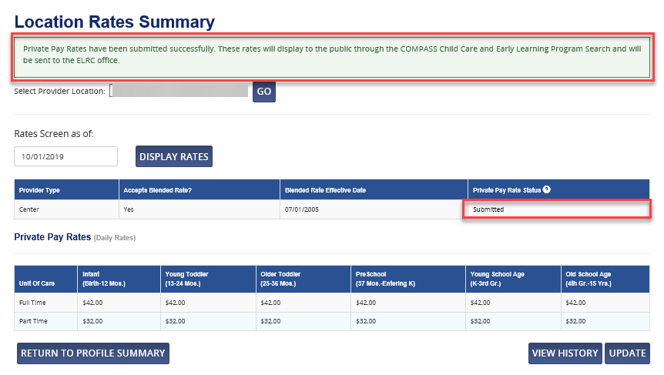

1. If the radio button for Save and Return Later was clicked, the confirmation message appears, and the Private Pay Rate Status is updated to **NOT SUBMITTED**.

